UNIT –IV:
Enterprise Management system –Technology of information systems-Database Management system- Object oriented Technology(OOT)-Conceptual Presentation-Client server Architecture.

Enterprise Management system
Enterprise management systems are software packages created with large businesses in mind. They allow for many applications and softwares to be controlled from a central location. Most of them are cloud-based, and sold in packages with specific departmental needs as their focus.
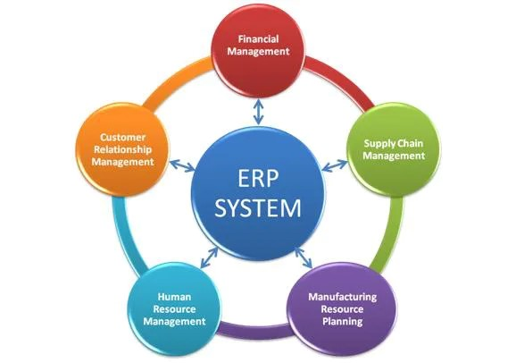

Customer Relationship Management (CRM)
This is software that manages a business’s interaction with existing and potential customers. CRM enables businesses to learn about their customers’ needs and purchasing behavior and uses this information to improve the quality of a business’s marketing plans and sales forecast. The ultimate goal of CRM is to ensure that businesses are connected to customers, enhance the efficiency of business processes, and maximize profitability.

2. Supply Chain Management (SCM)
This software efficiently manages supply chain activities such as product development, production, material sourcing, as well as information systems that coordinate these activities. It aims at providing businesses with a strategic advantage. SCM basically begins with the purchase of raw materials and continues to the final delivery of the product.

3. Enterprise Resource Planning (ERP)
This system integrates various software applications such as finance, human resources, inventory management, and purchasing. ERP enables organizations to get rid of duplications and discrepancies while sharing and accessing data in real-time.

The Basics of ERP
ERP is basically a single application with a set of modules. It focuses on:
- Inventory, facilities, and asset management
- Human resources
- Financial, including accounts receivable and payable, payroll, and general ledgers
Enterprise Resource Planning software is designed to enhance a business’s internal processes. It helps managers’ decision-making process by furnishing them with timely information. It also provides employees with real-time data and reports.

The Basics of EMS
EMS is more data-focused. EMS systems are large-scale software packages that track and control complex business operations. An effective EMS system should be able to accomplish the following:
- Automate the customer service process
- Store business data in a usable format that can be retrieved quickly
- Secure customer data
- Standardize critical processes
- Minimize the cost of doing business
- Streamline supply chain management
- Provide real-time access to data
- Ensure regulatory compliance
- Allow scalability of IT capabilities

Technology of information systems
An information system is a combination of software, hardware, and telecommunication networks to collect useful data, especially in an organisation. Many businesses use information technology to complete and manage their operations, interact with their consumers, and stay ahead of their competition.

1. Hardware – This is the physical component of the technology. It includes computers, hard disks, keyboards, iPads, etc. The hardware cost has decreased rapidly while its speed and storage capacity has increased significantly. However, the impact of the use of hardware on the environment is a huge concern today. Nowadays, storage services are offered from the cloud, which can be accessed from telecommunications networks.
2. Software – Software can be of two types, system software and application software. The system software is an operating system that manages the hardware, program files, and other resources while offering the user to control the PC using GUI. Application software is designed to manage particular tasks by the users. In short, system software makes the hardware usable while application software handles specific tasks.
An example of system software is Microsoft windows, and an example of application software is Microsoft Excel.
Large companies may use licensed applications which are developed and managed by software development companies to handle their specific needs. The software can be proprietary and open source, available on the web for free use.
3. Data – Data is a collection of facts and is useless by themselves, but when collected and organised together, it can be very powerful for business operations. Businesses collect all the data and use it to make decisions that can be analysed for the effectiveness of the business operations.
4. Telecommunications – Telecommunication is used to connect with the computer system or other devices to disseminate information. The network can be established using wired or wireless modes. Wired technologies include fiber optics and coaxial cable, while wireless technologies include radio waves and microwaves.

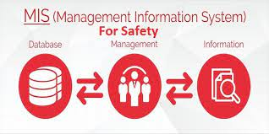

Types of information systems
There are various information systems, and the type of information system a business uses depends on its goal and objective. Here are the four main types of information systems:
- Operations support systems – The first type of information system is the operation support system. Such type of information system mainly supports a specific type of operation in a business. An example is the transaction processing system used in all banks worldwide. This type of information system enables the service provider to assess a specific process of business.
- Management information systems – This is the second category of information systems, consisting of hardware and software integration allowing the organisation to perform its core functions. They help in obtaining data from various online systems. The data thus obtained is not stored by the system; rather, it is analysed in a productive manner to help in the management of an organisation.
- Decision support systems – An organisation can make an informed decision about its operations using decision support systems. It analyses the rapidly changing information that cannot be determined in advance. It can be used in completely automated systems and human-operated systems. However, for maximum efficiency combination of human and computer-operated systems is recommended.
- Executive information systems – EIS or executive support system is the last category that serves as management support systems. They help in making senior-level decisions for an organisation.
Database Management system
What is DBMS? Database Management Systems (DBMS) are software systems used to store, retrieve, and run queries on data. A DBMS serves as an interface between an end-user and a database, allowing users to create, read, update, and delete data in the database.
database management system (DBMS) is system software for creating and managing databases. A DBMS makes it possible for end users to create, protect, read, update and delete data in a database. The most prevalent type of data management platform, the DBMS essentially serves as an interface between databases and users or application programs, ensuring that data is consistently organized and remains easily accessible.

The Role of DBMS in Information Systems
A DBMS plays a crucial role in both the creation and management of data. Without a database management system, running and managing data effectively is not possible. Serving as the intermediary between the user and the database, a DBMS provides users access to files stored in a database. It provides the end user with a single, integrated view of the data, and translates all applications it receives into complex operations that fulfil those requests. However, much of the internal complexity of the database is hidden from the users and application programs.
From enabling the sharing of data in the database among multiple applications or users to providing users with a single all-encompassing data repository, DBMS plays an important role in information systems. Following are some of the things a DBMS enables in information systems:

Better Data Access Within the Company
With a DBMS, users within a company can access, update and delete data in a database or information system. This information is easily available to users when the company’s information systems are integrated with the relational DBMS.

Stronger Relationships Between Data
A key function of database management systems is allowing different data sets to relate to one another. This makes a DBMS ideal for managing relationships between data sets in a systematic and simple way. This, in turn, allows managers to understand key statistics related to business operations and sales.

Improved Data Security
The more people access the data, the greater the risk of data security breaches. Generally, companies invest considerable time, effort and money to ensure proper use of their data. But, this does not always produce the desired outcomes. With a DBMS, organizations can ensure better enforcement of data privacy and security policies, which allows them to improve overall data security.
What structures exist in a relational database?
Relational databases include the following structures:
Database
A database is a logical grouping of data. It contains a set of related table spaces and index spaces. Typically, a database contains all the data that is associated with one application or with a group of related applications. You could have a payroll database or an inventory database, for example.
Table
A table is a logical structure made up of rows and columns. Rows have no fixed order, so if you retrieve data you might need to sort the data. The order of the columns is the order specified when the table was created by the database administrator. At the intersection of every column and row is a specific data item called a value, or, more precisely, an atomic value. A table is named with a high-level qualifier of the owner's user ID followed by the table name, for example TEST.DEPT or PROD.DEPT. There are three types of tables:
A base table that is created and holds persistent data
A temporary table that stores intermediate query results
A results table that is returned when you query tables.
Figure 1. Example of a DB2 table (department table)Example of a DB2 table (department table)
In this table we use:
Columns–The ordered set of columns are DEPTNO, DEPTNAME, MGRNO, and ADMRDEPT. All the data in a given column must be of the same data type.
Rows–Each row contains data for a single department.
Values–At the intersection of a column and row is a value. For example, PLANNING is the value of the DEPTNAME column in the row for department B01.
Indexes
An index is an ordered set of pointers to rows of a table. Unlike the rows of a table that are not in a specific order, an index must always be maintained in order by DB2®. An index is used for two purposes:
For performance, to retrieve data values more quickly
For uniqueness.
By creating an index on an employee's name, you can retrieve data more quickly for that employee than by scanning the entire table. Also, by creating a unique index on an employee number, DB2 will enforce the uniqueness of each value. A unique index is the only way DB2 can enforce uniqueness.
Creating an index automatically creates the index space, the data set that contains the index.
Keys
A key is one or more columns that are identified as such in the creation of a table or index, or in the definition of referential integrity.
Primary key
A table can only have one primary key because it defines the entity. There are two requirements for a primary key:
It must have a value, that is, it cannot be null.
It must be unique, that is, it must have a unique index defined on it.
Unique key
We already know that a primary key must be unique, but it is possible to have more than one unique key in a table. In our EMP table example, the employee number is defined as the primary key and is therefore unique. If we also had a social security value in our table, hopefully that value would be unique. To guarantee this, you could create a unique index on the social security column.

Foreign key
A foreign key is a key that is specified in a referential integrity constraint to make its existence dependent on a primary or unique key (parent key) in another table.

Object oriented Technology(OOT)
OOT TRANSITION APPROACHES
A successful technology transition effort does not occur overnight. There are different stages an organization must go through before a technology is fully integrated into its operations. Following is a discussion of different approaches some organizations have used in introducing OOT. Note that in all of the successful transitions that were observed, the initial use of OOT was small in scale and exploratory. The progression from this initial use to a mainstream technology did not happen immediately for these organizations. Understanding this is valuable since it is easy to set unrealistic expectations regarding any technology transition.
ORGANIZATIONAL READINESS
One of the issues that arises in making a change of any sort is whether the organization is ready for transitioning a new technology. This decision is unique to each organization, and an assessment of the organization can determine the degree, pace, and manner in which OOT is introduced. Whatever transition approach is used, it must consider the capabilities, resources, and willingness of the organization. For that reason, there is no single set approach for all organizations.
But certain elements are required for an organization to achieve an established OOT capability: a. Organizational commitment. Organizational commitment is required within all levels, from the development team to senior management. It will be necessary to communicate to all levels the business context and rationale for such a change. b. Resources. Resources are essential since this transition will require new tools and training. Providing resources can be a concern especially when there are short-term pressures to reduce costs. Management needs to take a long-term perspective regarding a transition. c. Time.
Sufficient time must be allowed for an organization to absorb the changes that the new technology brings and to show benefits from its use. Here the longterm perspective and sufficient resources will sustain the period of this transition. An organization should expect a one- to five-year conversion time, depending upon the capabilities of the development team and the level of support it receives.
SUPPORT FOR OOT TRANSITION
When an organization decides to introduce OOT, it is often helpful to acquire external support for the transition. External support may consist of OOT training and education in development approaches and object-oriented languages and tools, as well as on-site mentoring and consultation for specific projects. It may also be helpful to get basic software engineering support if the development teams are unfamiliar with issues such as software life cycle management, configuration management, and quality control.

Conceptual Presentation
1) Define problem:
The first step in conceptual design is to clearly understand and define the problem to be solved. The information needs of the organization are to be identified and understood in this step, which can be determined by understanding the mission, objectives and operating plans
for the business.
2) Set system objectives:
System objectives should be stated in quantitative terms. For example, ‘pay salary to 100 percent employees by the last day of the month’.
3) Identify constraints:
System constraints may be classified into two categories
a) External constraints
These are external to the organization. For example constraints imposed by the customers, the government and the suppliers.
b) Internal constraints
These are imposed from within the organization. For example, non-cooperation and lack of support from top management, resource constraints like manpower, time and money etc.
4) Determine information needs:
For determination of information needs, users should specify:
a) What they want out of an information system and
b) Items of information that are needed to achieve the predetermined objectives.
5) Determine information sources:
Sources of information may be classified as given below:

a) Internal and external records:
The internal records may be in written form like files, inputs and outputs, correspondence, reports etc., whereas external records may include trade publications, government statistics, etc.
b) Managers and operating personnel:
User-managers and operating staff may be an important source. However, gathering data from the source involves interviewing the managers and operating personnel, which requires proper planning and skill.
6) Develop various designs:
More than one alternative conceptual designs are to be developed which are compared to select the optimum one, which:
a) Meets the requirements of the users/organizations and
b) Is cost effective
Various criteria can be adopted as a basis for evaluating the designs such as economic, performance, operational etc.
7) Documentation of the conceptual design:
The documentation involves:
a)Overall system flow
b) System inputs
c)System outputs, and
d) Other documentations like activity sheet and system description, etc.
8) Report preparation:
The report prepared should mention the problem, objectives and an overall view of the system. Justifications for selecting the alternatives and many more.

Client server Architecture
The Client-server model is a distributed application structure that partitions task or workload between the providers of a resource or service, called servers, and service requesters called clients. In the client-server architecture, when the client computer sends a request for data to the server through the internet, the server accepts the requested process and deliver the data packets requested back to the client. Clients do not share any of their resources. Examples of Client-Server Model are Email, World Wide Web, etc. How the Client-Server Model works ? In this article we are going to take a dive into the Client-Server model and have a look at how the Internet works via, web browsers. This article will help us in having a solid foundation of the WEB and help in working with WEB technologies with ease.
- Client: When we talk the word Client, it mean to talk of a person or an organization using a particular service. Similarly in the digital world a Client is a computer (Host) i.e. capable of receiving information or using a particular service from the service providers (Servers).
- Servers: Similarly, when we talk the word Servers, It mean a person or medium that serves something. Similarly in this digital world a Server is a remote computer which provides information (data) or access to particular services.
So, its basically the Client requesting something and the Server serving it as long as its present in the database.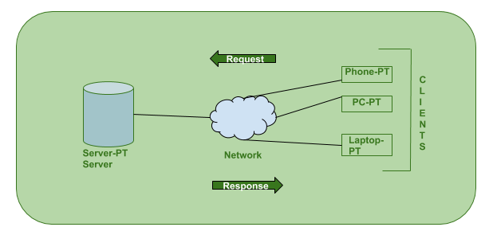How the browser interacts with the servers ? There are few steps to follow to interacts with the servers a client.
- User enters the URL(Uniform Resource Locator) of the website or file. The Browser then requests the DNS(DOMAIN NAME SYSTEM) Server.
- DNS Server lookup for the address of the WEB Server.
- DNS Server responds with the IP address of the WEB Server.
- Browser sends over an HTTP/HTTPS request to WEB Server’s IP (provided by DNS server).
- Server sends over the necessary files of the website.
- Browser then renders the files and the website is displayed. This rendering is done with the help of DOM (Document Object Model) interpreter, CSS interpreter and JS Engine collectively known as the JIT or (Just in Time) Compilers.
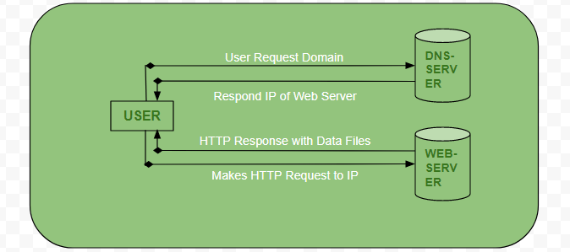Advantages of Client-Server model:
- Centralized system with all data in a single place.
- Cost efficient requires less maintenance cost and Data recovery is possible.
- The capacity of the Client and Servers can be changed separately.
Disadvantages of Client-Server model:
- Clients are prone to viruses, Trojans and worms if present in the Server or uploaded into the Server.
- Server are prone to Denial of Service (DOS) attacks.
- Data packets may be spoofed or modified during transmission.
- Phishing or capturing login credentials or other useful information of the user are common and MITM(Man in the Middle) attacks are common.

The Characteristics of Client-Server Architecture
Client-server architecture typically features the following characteristics:
- Client and server machines typically require different hardware and software resources and come from other vendors.
- The network has horizontal scalability, which increases the number of client machines and vertical scalability, an then moves the entire process to more powerful servers or a multi-server configuration.
- One computer server can provide multiple services simultaneously, although each service requires a separate server program.
- Both client and server applications interact directly with a transport layer protocol. This process establishes communication and enables the entities to send and receive information.
- Both the client and server computers need a complete stack of protocols. The transport protocol employs lower-layer protocols to send and receive individual messages.
*************

